**Spring MVC- Twilio OTP validation.**

**Prerequisites:**

1. **Spring tool suite**
2. **Twilio trail account.**
3. **Create account and setup in twilio.**
4. **Login to twilio site** <https://www.twilio.com/try-twilio> **and create a trial account with email.**
5. **Verify your email and mobile number.**
6. **They will provide ACCOUNT-SID and AUTH-TOKEN note these two keys.**
7. **In the same page request for phone number.**
8. 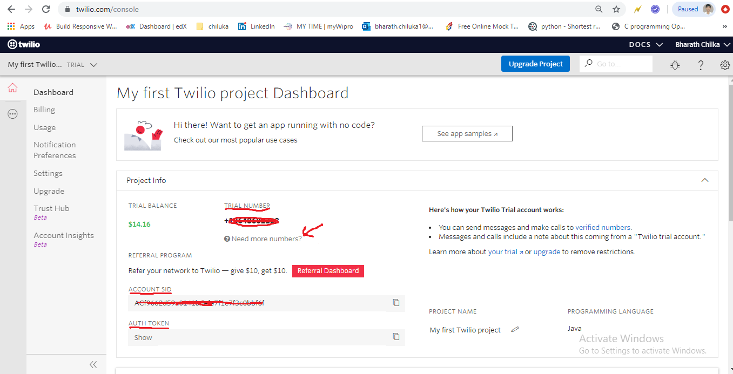**open the console, there you can note down all keys and mobile number.**

1. **Create a Verification Service, it is the set of common configurations used to create and check verifications.(** <https://www.twilio.com/console/verify/services>)

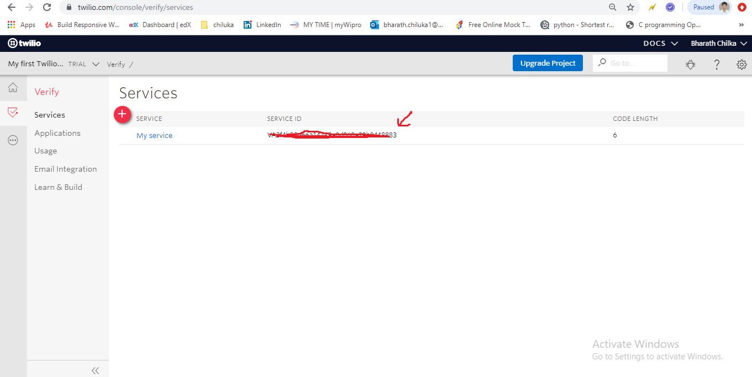

1. **Note down the your verification SERVICE_ID.(while creating service we can give different length of OTP and expire time of OTP).**
2. **Spring app**
3. **Create a spring boot application in spring tool suite**
4. **Create sample index page and html form with required fields to validate the mobile with otp.**
5. **Create a controller which consist of below two apis**
6. **Send otp**
7. **Verify otp**
8. **Both these above methods should internally call the verification service methods for that we create another verification service.class**

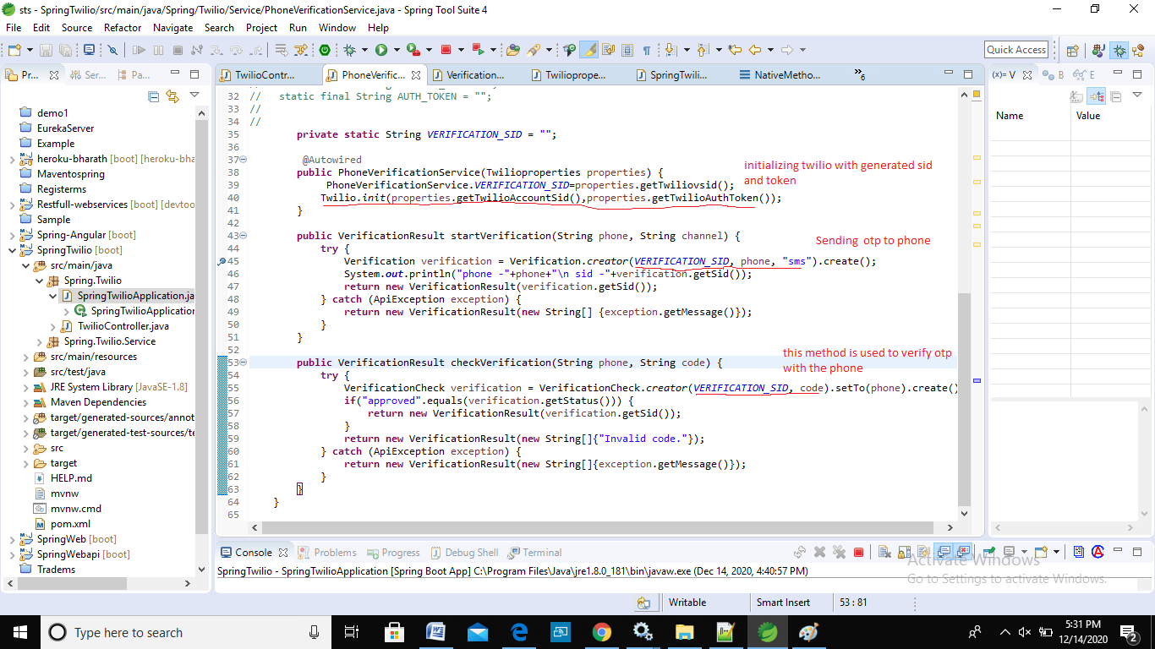

1. **My Complete code link (**<https://github.com/Bharath-1997/Spring_MVC_TWILIO_OTP>).

**For more information refer (**<https://github.com/TwilioDevEd/verify-v2-quickstart-java>

[**https://github.com/TwilioDevEd/account-security-quickstart-spring**](https://github.com/TwilioDevEd/account-security-quickstart-spring)